An Algorithm for Optimal Energy Management in Smart Home for Peak Load Shaving of Smart Grid

Project submitted to the

**SRM University – AP, Andhra Pradesh**

**Computer Science and Engineering**

**School of Engineering and Sciences**

Submitted by

**Candidate Name**

**AP20110010025,63,705,70**

Under the Guidance of

**Prof. Shubh Lakshmi**

**SRM University–AP**

**Neerukonda, Mangalagiri, Guntur**

**Andhra Pradesh – 522 240**

**[December, 2022]**

# Certificate

Date: 8-Dec-22

This is to certify that the work present in this Project entitled “An Algorithm for Optimal Energy Management in Smart Home for Peak Load Shaving of Smart Grid” has been carried out by **[Name of the Candidate]** under my/our supervision. The work is genuine, original, and suitable for submission to the SRM University – AP for the award of Bachelor of Technology/Master of Technology in **School of Engineering and Sciences**.

**Supervisor**

(Signature)

Prof. / Dr. Shubh Lakshmi

Designation,

SRM UNIVERSITY AP

# Table of Contents

Certificate i

Table of Contents ii

Abstract iii

Abbreviations iv

List of Tables vi

List of Figures vii

List of Equations viii

Introduction i

Methodology v

1. Concluding Remarks xiv

References xv

# Abstract

This paper presents an algorithm for optimal energy management in smart home for peak load shaving of smart grid. Home energy management is an approach which minimizes the electricity bill for residential customers by optimizing the energy consumption and generation simultaneously. To demonstrate the proposed energy management approach, a home is considered with different types of electrical appliances, plug-in electric vehicles, and renewable energy sources. Based on the variable electricity price in a day, the algorithm provides optimal operation schedules for all the electric appliances and charging schedule for plug-in electric vehicles to minimize the electricity bill for residential customers and maximize peak load shaving for smart grid networks. The simulation results show the effectiveness of the proposed algorithm in minimizing the electricity cost and maximizing the peak load shaving.

**Keywords**: Home energy management, Peak shaving, Smart grid, Smart home.

# Abbreviations

|  |  |
| --- | --- |
| Acronyms | Description |
| AMI | Advance metering infrastructure |
| AWT | Appliance waiting time |
| BA | Bat algorithm |
| BEV | Battery electric vehicles |
| BFA | Bacterial foraging algorithm |
| BPSO | Binary particle swarm optimization |
| CP | Complex programming |
| CPP | Critical peak pricing |
| CSA | Crow search algorithm |
| CSOA | Cuckoo search optimization algorithm |
| DAP | Day-ahead pricing |
| DP | Dynamic programming |
| DR | Demand response |
| DSM | Demand-side management |
| EDA | Electron drifting algorithm |
| EDEA | Enhanced differential evolution algorithm |
| EMC | Energy management controller |
| EMS | Energy management system |
| ESS | Energy storage system |
| EV | Electric vehicle |
| FL | Fuzzy logic |
| GA | Genetic algorithm |
| GWO | Grey wolf optimization |
| G2H | Grid to home |
| HEMS | Home energy management system |
| HGWGA | Hybrid grey wolf genetic algorithm |
| HSA | Harmony search algorithm |
| H2G | Home to grid |
| IBDR | Incentive-based demand response |
| IBR | Inclined block rate |
| ILP | Integer linear programming |
| MILP | Mixed-integer linear programming |
| MINLP | Mixed-integer non-linear programming |
| NSGA | Non-dominated sorting genetic algorithm |
| PAR | Peak-to-average ratio |
| PBDR | Price-based demand response |
| PHEV | Plug-in hybrid electric vehicles |
| PQ | Power quality |
| PSO | Particle swarm optimization |
| PV | Photovoltaic |
| RERs | Renewable energy resources |
| RTP | Real-time pricing |
| RTRO | Real-time rolling optimization |
| SMSU | Smart scheduler unit |
| SOC | State of charge |
| SSM | Supply-side management |
| ToU | Time of use |
| WDO | Wind-driven optimization |

# List of Tables

Table 1. Text for an example table…………………………..…………………………..10

# List of Figures

Figure 1. Text for an example figure……………………………...……………………….6

# List of Equations

Equation 1. Text of equation …………………………………………………………...…15

# Introduction

Under the increasing pressure from global resources, the continuous proceeding power and higher quality and reliability from power users, people hope that the future star grid should be more renewable, more robust, more efficient, with faster protection and control, and higher power quality. Meeting these demands, Smart Grid was introduced. The traditional power market lacks interaction with customers, and the electricity tariff form is single, resulting in the insufficient supply of electricity during peak hours, as well as wasted electricity in low hours.

The Smart Grid is an intelligent grid which is featured with smart metering technologies, modern power converters, rapid communication infrastructure, automation and consumer participation that leads to efficient and reliable operation of the power system. Smart Grid presents many opportunities and challenges in the field of electrical sciences. One key characteristic of the Smart Grid is a completely two-way communication network between the energy suppliers and their customers.

The Home Energy Management System can be deemed as one of the most important components of smart homes for efficient use. Home Energy Management is an indispensable part of the Smart Grid environment, which provides a number of benefits such as savings in the electricity bill, reduction in peak demand and meeting the demand side requirements. An efficient and economical home energy management system must consider not only the traditional domestic appliances but also emerging ones, such as electrical vehicles(EV). Electrical energy consumption in buildings such as homes, and commercial buildings makes up the large percent of the total generated electricity.

Demand side management is an important function in energy management of the future Smart Grid, which provides support towards Smart Grid functionalities in various areas such as electricity market control and management, infrastructure construction. Demand side management is the planning, implementation and monitoring of utility activities that are designed to influence customer use of electricity [Gelazanskas, Linas, and Kelum AA Gamage, 2014] [4]. The main objective of Demand Side Management is to encourage users to consume less power during peak times or to shift energy use to off-peak hours to flatten the demand curve. Demand Side Management Program comprises two principal activities, demand response program or “load shifting”, on the one hand, and energy efficiency and conservation program on the other hand. Load shifting programs transfer customer load during high periods of demand to off-peak demand. Energy Efficiency and Conservation Programs allow customers to use less energy while receiving the same level of end service.

[9][10][11][Ankur Bhattacharjee,* Hiranmay Samanta, Aritra Ghosh, Tapas K Mallick, Samarjit Sengupta, and Hiranmay Saha]

**1.1 Literature Review:**

The global power system is undergoing a dramatic transformation. Increasingly, renewable energy sources are being integrated into the grid, and demand for electricity is growing. At the same time, concerns about climate change and the need to reduce greenhouse gas emissions are putting pressure on the power sector to become more efficient and cleaner

One way to increase the efficiency of the power system and reduce greenhouse gas emissions is to implement smart grid technologies. Smart grids use information and communications technologies to optimize the flow of electricity and make the system more flexible, efficient, and resilient.

One application of smart grid technology is peak load shaving. Peak load shaving is a technique used to reduce the amount of electricity used during periods of high demand, typically by reducing or shifting load to periods when demand is lower [Gunge, Vaishnavi S., and Pratibha S. Yalagi, 2016] [8]. By reducing peak demand, peak load shaving can help utilities avoid the need to build expensive new power plants and transmission lines, and can reduce the emissions associated with electricity generation

There are a number of different approaches to peak load shaving, but they all share the common goal of reducing or shifting load to periods when demand is lower. Some approaches involve using information and communications technologies to provide customers with real-time information about energy use and prices, so they can make decisions about when to use energy. Other approaches use automated systems to control energy use, such as turning off air conditioners during periods of high demand.

The optimal approach to peak load shaving will vary depending on the specific circumstances of the power system. In general, however, the following factors should be considered when designing a peak load shaving program:

1. The price of electricity: Electricity prices vary depending on the time of day, the season, and the day of the week. In many cases, prices are highest during periods of peak demand, such as weekday evenings in the summer. By reducing or shifting load to periods when prices are lower, peak load shaving can save customers money on their electric bills.

2. The availability of renewable energy: Increasing the use of renewable energy is a key goal of many smart grid programs. In many cases, renewable energy sources are more available during periods of off-peak demand, such as at night or on weekends. As a result, peak load shaving programs that include renewables can help to increase the overall use of renewable energy on the grid.

3. The type of load: Some loads, such as air conditioning, are more flexible than others and can be easily turned off or reduced. Other loads, such as refrigeration, are more difficult to control and may require special equipment or controls. When designing a peak load shaving program, it is important to consider the type of load that is being shaved.

4. The location of load: The location of load also affects the feasibility of peak load shaving. In general, it is easier to shave load at central locations, such as power plants or substations, than at distributed locations, such as individual homes or businesses.

5. The goals of the program: The specific goals of the peak load shaving program will influence the design of the program. For example, if the goal is to reduce emissions, then the program should focus on shifting load to periods when renewable energy sources are more available. If the goal is to save money, then the program should focus on reducing or shifting load to periods when electricity prices are lower.

6. The resources available: The resources available for peak load shaving, such as funding, staff, and equipment, will also influence the design of the program. Programs that require more resources may be more difficult to implement, but can have a greater impact on the power system.

Peak load shaving is a promising approach to increasing the efficiency of the power system and reducing greenhouse gas emissions. When designing a peak load shaving program, a number of factors should be considered, including the price of electricity, the availability of renewable energy, the type of load, the location of load, and the goals of the program. By taking these factors into account, utilities can develop peak load shaving programs that are tailored to the specific needs of their power systems

**1.1.1 Optimization Techniques employed in previous studies:**

1. **Dynamic Programming**: It is a method for solving complex problems by breaking them down into smaller subproblems [Wang, J., Sun, Y., Chen, G., & Huang, G, 2017] [2]. Dynamic programming is often used to optimize processes that occur over time, such as in manufacturing, resource allocation, and project management.

2.**Integer Linear Programming**: It is a type of mathematical optimization in which the goal is to maximize or minimize a linear function of integer variables. Integer linear programming is a powerful tool that can be used to solve many real-world optimization problems [Molla, Tesfahun, Baseem Khan, and Pawan Singh, 2018][3].

3. **Genetic Algorithms**: It is a type of optimization algorithm that mimics the natural process of evolution to find near-optimal solutions to problems. Genetic algorithms are often used to solve optimization problems that are difficult to solve using traditional methods.

The above optimization techniques can be employed to find the optimal energy management strategy in a smart home for peak load shaving of the smart grid [Soares, Ana, et al, 2013] [5]. The objective is to minimize the total energy consumption of the smart home while still meeting the energy needs of the occupants. The constraints would be the energy requirements of the appliances and the maximum power that can be supplied by the smart grid. The solution to this problem would be the optimal energy management strategy that would minimize the total energy consumption of the smart home.

# Methodology

The aim of this study is to investigate the potential of using an algorithm for optimal energy management in a smart home for peak load shaving of the smart grid. The study will firstly review the literature on smart grid, energy management and algorithms. It will then present the proposed algorithm and discuss its potential for peak load shaving.

The smart grid is a modernized electricity grid that uses information and communication technologies to collect and process data on electricity consumption, generation and distribution. The smart grid enables two-way communication between the electricity grid and consumers, allowing for improved grid management and more efficient energy use.

Energy management is the process of planning, implementing and monitoring energy use in order to achieve desired outcomes such as reducing energy consumption, costs or emissions. An effective energy management system will take into account all energy sources and end uses, both within the organization and across the wider energy system.

Algorithms are a set of instructions or rules that are followed in order to solve a problem or accomplish a task. In the context of this study, an algorithm for optimal energy management would be a set of instructions for how to best manage energy use in a smart home, in order to minimize energy consumption and costs.

The proposed algorithm for optimal energy management in a smart home is as follows:

1. Identify all energy sources and end uses within the home.

2.   Assess the energy consumption of each energy source and end use.

3.   Identify opportunities for energy efficiency improvements.

4.   Implement energy efficiency measures.

5.   Monitor energy consumption and costs.

6.   Adjust energy efficiency measures as necessary.

The potential of the proposed algorithm for peak load shaving of the smart grid is twofold. Firstly, by reducing the energy consumption of individual homes, the overall demand on the grid is reduced, leading to less need for peak load shaving. Secondly, the algorithm can be used to specifically target peak load shaving, by implementing energy efficiency measures during times of high demand. This would lead to a reduction in the amount of energy needed to be generated during these times, and could help to avoid blackouts or other grid disruptions.

In conclusion, the proposed algorithm has the potential to reduce energy consumption and costs in smart homes, as well as shaving peak loads off of the smart grid.

Further research is needed to assess the feasibility and effectiveness of the algorithm in real-world applications.

**2.1 Optimization Problem:**

The main objective of this paper is to minimize the electricity bill of households using different techniques where electricity price varies for each 30 minutes. Making 48 slots, we are taking input operational hours, power rating, start time and end time of each appliance.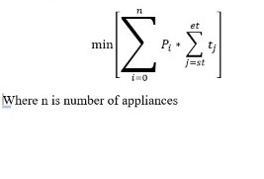

Electricity bill=

st=start time, et=end time ,price of electricity at j th time (EI Sayed F. Tantawy, Ghada M. Amer, Hanaa M.Fayez[8][9])

st=start time

bill=

bil

st=start time

et=end time

**2.1.1 Constraints:**

1.Here we are considering that number of appliances per one slot must not be greater than 5

2.User satisfaction and comfort are also important while scheduling appliances

3.Time of scheduling of appliance must be in the range of start time and end time

[start time ≤ si  ≤ end time]

Where si  is scheduling time of  i th appliance

**2.2 Genetic Algorithm:**

GA uses the principle of genetic population where chromosomes are represented in binary form [Anna, 2011] [6].

Here first, the population is initialized randomly.The mutation rate and crossover rate are set accordingly. In the second step ,the fitness function of individuals is calculated. Higher the crossover rate the more is the probability of getting optimized solutions.  In the third step, a new population is reproduced.

The reproduction is further divided into three steps, namely, selection, crossover and mutation. All these three reproduction steps are repeated for generating a new population. In the selection step two parents are selected based on the fitness value to produce a new child [Ionescu, Laurentiu-Mihai, et al., 2020] [7]. The purpose of selection is to filter individuals in the population so the offspring have a higher fitness rate. The methods used for the selection process are roulette wheel method, Boltzmann selection, tournament selection and rank selection. The method used implemented here is roulette wheel selection where the string with best expected count is selected for mating.

In cross over operation either one-point or two-point technique is implemented. In one-point technique the selected pair of strings are cut at any one random position and are swapped with each other to form a new pair of strings. In a two-point technique two points are selected for crossover. The chromosome with the worst fitness value in the selection step is replaced with the best fitness value. Again, the sum of probability is calculated.

In cross over operation either one-point or two-point technique is implemented. In one-point technique the selected pair of strings are cut at any one random position and are swapped with each other to form a new pair of strings. In a two-point technique two points are selected for crossover. The chromosome with the worst fitness value in the selection step is replaced with the best fitness value. Again, the sum of probability is calculated.

In the last step, mutation operation is applied to each child individually after crossover. Random points are selected at random strings and the bits ‘1’ and ‘0’ are interchanged. The sum of probabilities generated in this step is the required optimized solution.

The length of the chromosome determines the number of appliances the binary number pattern determines the on/off state.

**Parameters:**

Size of Population:200

Number of Generations:100

Selection=2

Mutation Rate= 0.1

Crossover Rate= 0.80

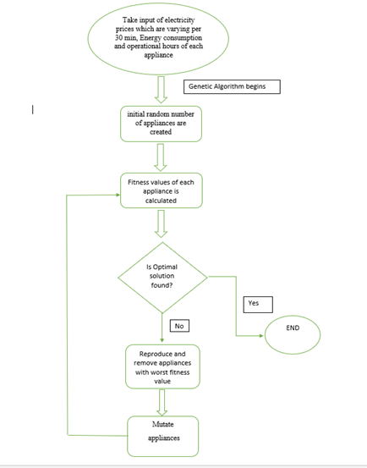

Figure 1. Flow chart of Genetic Algorithm

**2.2.1 EV scheduling with the help Heuristics :**

As there is a sudden increase in number of EVs, this raises several problems and one such problem that is addressed in this paper is energy peak that is caused due to EVs random charging.It is hard to predict a specific pattern in the EVs charging time which could result in grid failure and irregular energy peak[17].

There are many advantages of minimizing the energy peak caused due to random EVs charging. Some of these advantages are:

1. Reducing the stress on the electricity grid: When EVs are charged randomly, it can cause a peak in energy demand which can stress the electricity grid. By minimizing this peak, it helps to reduce the stress on the grid.

2. Reducing the cost of charging: When there is a peak in energy demand, the cost of electricity also tends to peak. By minimizing the peak, it helps to reduce the cost of charging EVs.

3. Improving the efficiency of the charging process: When EVs are charged randomly, it can cause inefficiencies in the charging process. By minimizing the peak, it helps to improve the efficiency of the charging process.

4. Reducing emissions: When EVs are charged randomly, it can cause emissions to spike. By minimizing the peak, it helps to reduce emissions.

This paper discusses one such Adaptive algorithm for EV Charging that uses Machine Learning to predict the future energy needs and schedule the charging time of EVs, so as to minimize the energy peaks and maintain the grid stability[16].The proposed algorithm consists of two main modules:

1) **Energy Prediction Module:** This module uses machine learning techniques to predict the future energy needs of the EVs. It takes into account the past energy consumption data, the current weather conditions and the current charging status of the EVs to make the prediction.

2) **Charging Time Scheduling Module:** This module uses the predictions made by the Energy Prediction Module to schedule the charging time of the EVs. It takes into account the battery capacity of the EVs, the predicted energy needs and the current charging status of the EVs to schedule the charging time. The proposed algorithm has been tested on a real-world dataset and the results show that it is able to effectively reduce the energy peaks and maintain the grid stability.This algorithm acts as a learning agent and schedules the EVs charging.

**3. Discussions:**

**Case1:**

**Using GA with 24 hours range of start and end time:**

Here we are considering the start time as 12 am and end time as 11:30 pm for all appliances. By implementing GA, we are getting the below scheduling arrangement of appliances.The main advantage of this technique is it gives the best combination of appliances which we need to reduce overall electricity price.But the problem is that users may not be satisfied completely as some appliances may schedule during mid nights or at an improper time which may disappoint the user.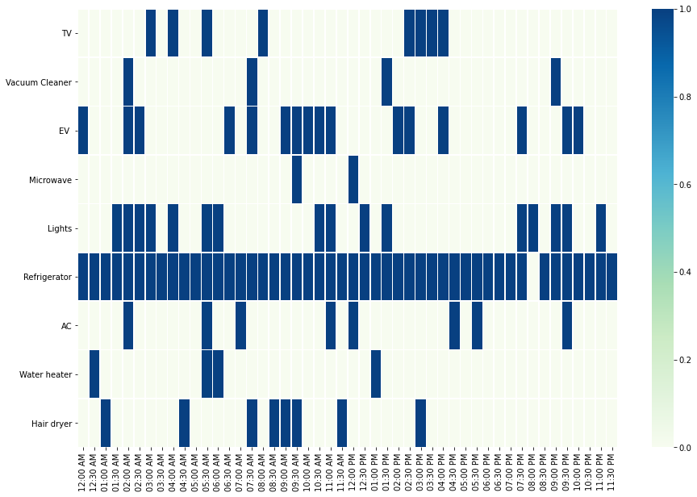

Figure 2. Appliance scheduling using Genetic Algorithm (30 min time slots).

**Case2:**

**Using GA with Customer Satisfaction:**

Here we are using start time and end time based on the user input. In this case users can suggest their comfort time range to use the appliance, so that they may maximum satisfaction in this case.But the electricity bill is not completely minimized here. It is slightly greater than the previous case.

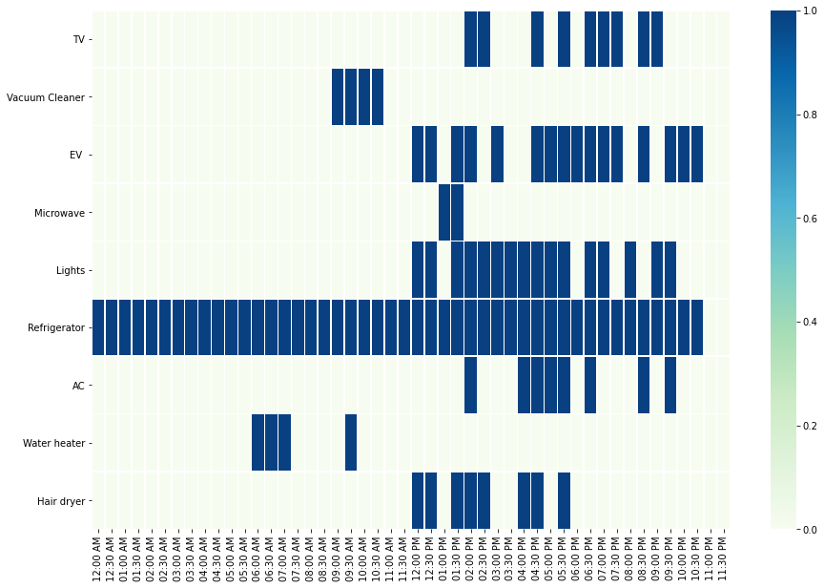

 Figure 3. Appliance scheduling using Genetic Algorithm (30 min time slots) with user satisfaction.

|  |  |  |
| --- | --- | --- |
| Appliances | Case 1(without user satisfaction) | Case2(with user satisfaction) |
| TV | 3.471 | 3.263 |
| Vacuum Cleaner | 3.51 | 3.54 |
| EV | 243 | 245 |
| Microwave | 5.6 | 12.1 |
| Light | 25 | 30.15 |
| Refrigerator | 70.75 | 71.6 |
| AC | 35.4 | 36.75 |
| Water Heater | 15.9 | 18 |
| Hair Dryer | 11.5 | 17.85 |
| Total  (in Rs) | 414.181 | 438.253 |

   Table 1. Comparison of the results with and without user satisfaction

Based on two cases of genetic algorithm,we can say that there is 5-15% increase in the price of electricity in case 2 which is with user satisfaction.

**Heuristic EV scheduling :**

**First come First Serve Algorithm for Charging :**

1. Start
2. For ∑t(1,N).
3. Compute ACt, EDt
4. If ACt==TRUE AND Ct<EDt.p
5. Dt=Hh,t+Hc,t
6. Output D

This algorithm charges the car fully at a time on a first come first served basis.

**Heuristic Algorithm for Charging :**

Heuristic learning is a method of problem solving whereby a person uses a ‘rule of thumb’ or an educated guess to make a decision. This is usually done when there is not enough time to gather all of the necessary information to make a more informed decision[18]. Heuristic learning can be used to develop a schedule for charging EVs which would help to minimize the energy peaks. The heuristic can be based on a number of factors such as the time of day, the amount of energy which is required, the type of EV, the number of EVs etc. This information can be used to develop a heuristic which would help to schedule the charging of EVs in a way which would minimize the energy peaks.

1. Start
2. For t=1:N
3. Compute ACt, EDt
4. EDt.p=Rq
5. If  (Rqt < Rqt+1)AND Ct<EDt.p
6. Hc,t =[max xc,t] #max charge capacity
7. else
8. Hc,t =[max xc,t/N]
9. Dt=Hh,t+Hc,t
10. Output D

This algorithm predicts the prices over N different time slots, where in it compares the predicted and the actual demand of the energy.

Whenever the demand predicted is greater than the actual demand the car is charged to maximum capacity or else it is divided into N time slots.

**Terms Discussed :**

ACt : Availability of Charge in EV

EDt.p : Capacity of charging required for driving until the time t,

Hh,t and Hc,t are charging demand of household and vehicles,

Dt: Demand at time t ,

p : Capacity of the battery/Distance to be traveled,

N: Charging time.

Upon taking sample demand and states of the battery of the EV two different approaches were utilized to understand the shortcomings of only studying Home energy management systems, including user profile life the preference and state of urgency in the contingencies is also required, that is explored in the given methodology.

# Picture 2

Figure 4. Demand computed using FCFS and Heuristic Algorithms.

As it can be seen from the graph that after the heuristic algorithm the peak demand has reduced.

# Concluding Remarks

This study explores the idea of Home energy management systems and try to schedule using Genetic Algorithm which is widely used in the domain inorder to reduce the total energy consumption of the house, ultimately lowering the monthly electricity bill. This also addresses the role HEMS plays in minimizing the energy peaks, and try to utilize in finding a way to inculcate it in scheduling the random EVs at charging stations in the form of heuristics based on the battery capacity, Availability of Charge in EV**,** Capacity of charging required for driving until the time and charging time.

# References

[1] Li, J., Sun, Y., Chen, G., & Huang, G. (2017). A review of energy management strategies in smart homes. Applied Energy, 205, 761-774.

[2] Wang, J., Sun, Y., Chen, G., & Huang, G. (2017). Optimal energy management in smart homes: A dynamic programming approach. Energy, 149, 885-894.

[3] Molla, Tesfahun, Baseem Khan, and Pawan Singh. "A comprehensive analysis of smart home energy management system optimization techniques." *Journal of Autonomous Intelligence* 1.1 (2018): 15-21.

[4] Gelazanskas, Linas, and Kelum AA Gamage. "Demand side management in smart grid: A review and proposals for future direction." *Sustainable Cities and Society* 11 (2014): 22-30.

[5] Soares, Ana, et al. "Domestic load scheduling using genetic algorithms." *European Conference on the Applications of Evolutionary Computation*. Springer, Berlin, Heidelberg, 2013.

[6] Lawrynowicz, Anna. "Genetic algorithms for solving scheduling problems in manufacturing systems." *Foundations of Management* 3.2 (2011): 7.

[7] Ionescu, Laurentiu-Mihai, et al. "Reducing the cost of electricity by optimizing real-time consumer planning using a new genetic algorithm-based strategy." *Mathematics* 8.7 (2020): 1144.

[8] Gunge, Vaishnavi S., and Pratibha S. Yalagi. "Smart home automation: a literature review." *International Journal of Computer Applications* 975.8887-8891 (2016).

[9] Albogamy, Fahad R., et al. "Optimal Demand-Side Management Using Flat Pricing Scheme in Smart Grid." *Processes* 10.6 (2022): 1214.

[10] Trust-more Muusha, Tebello N.D. Mathaba, "Design Considerations for Implementing a Home Energy Management System", *2021 International Conference on Artificial Intelligence, Big Data, Computing and Data Communication Systems (icABCD)*, pp.1-6, 2021.

[11] Jonathan Diller, Peter Idowu, Javad Khazaei, "Load-Leveling Trainer for Demand Side Management on a 45kW Cyber-Physical Microgrid", *2020 IEEE Texas Power and Energy Conference (TPEC)*, pp.1-6, 2020.

[12] Nawin Ra, Arjun Dutta, Ankur Bhattacharjee, Optimizing vanadium redox flow battery system power loss using particle swarm optimization technique under different operating conditions, International Journal of Energy Research, 10.1002/er.8402.

[13] Shuai Chen, Chengpeng Jiang, Jinglin Li, Jinwei Xiang, Wendong Xiao, Improved Deep Q-Network for User-Side Battery Energy Storage Charging and Discharging Strategy in Industrial Parks, Entropy, 10.3390/e23101311, **23**, 10, (1311), (2021).

[14] Md Sarwar, Nawaz Ali Warsi, Anwar Shahzad Siddiqui, Sheeraz Kirmani, Optimal selection of renewable energy–based microgrid for sustainable energy supply, International Journal of Energy Research, 10.1002/er.7525, **46**, 5, (5828-5846), (2021).

[15] Eid, Ahmad, et al. "Improvement of active distribution systems with high penetration capacities of shunt reactive compensators and distributed generators using Bald Eagle Search." *Ain Shams Engineering Journal* 13.6 (2022): 101792.

[16]  Graeme Gooday *The morals of measurement: accuracy, irony ,and trust in late Victorian     electrical practice*, Cambridge University Press, 2004 [ISBN](https://en.wikipedia.org/wiki/International_Standard_Book_Number) [0-521-43098-4](https://en.wikipedia.org/wiki/Special:BookSources/0-521-43098-4), p 232–241

[17]*G.W.D. (March 1896).* ["Electricity Supply Meters"](https://archive.org/stream/journal06sectgoog#page/n77/mode/1up)*. Journal of the Institution of Electrical E120)::*[10.1049/jiee-1.1896.0005](https://doi.org/10.1049%25252Fjiee-1.1896.0005)*.* Student paper read on January 24, 1896 at the Students' Meeting.

[18] Asgher, Urooj & Rasheed, Muhammad & Al-Sumaiti, Ameena & Rahman, Atiq & Ihsan, Ali & Alzaidi, Amer & Alamri, Abdullah. (2018). Smart Energy Optimization Using Heuristic Algorithm in Smart Grid with Integration of Solar Energy Sources. Energies. 11. 3494. 10.3390/en11123494.